John 4:1-43
Outside the city of Sychar^{G4965}, Jesus meets with a Samaritan woman at Jacob’s well, near to the parcel of ground that Jacob gave to his son Joseph ().
Genesis 12:6,7
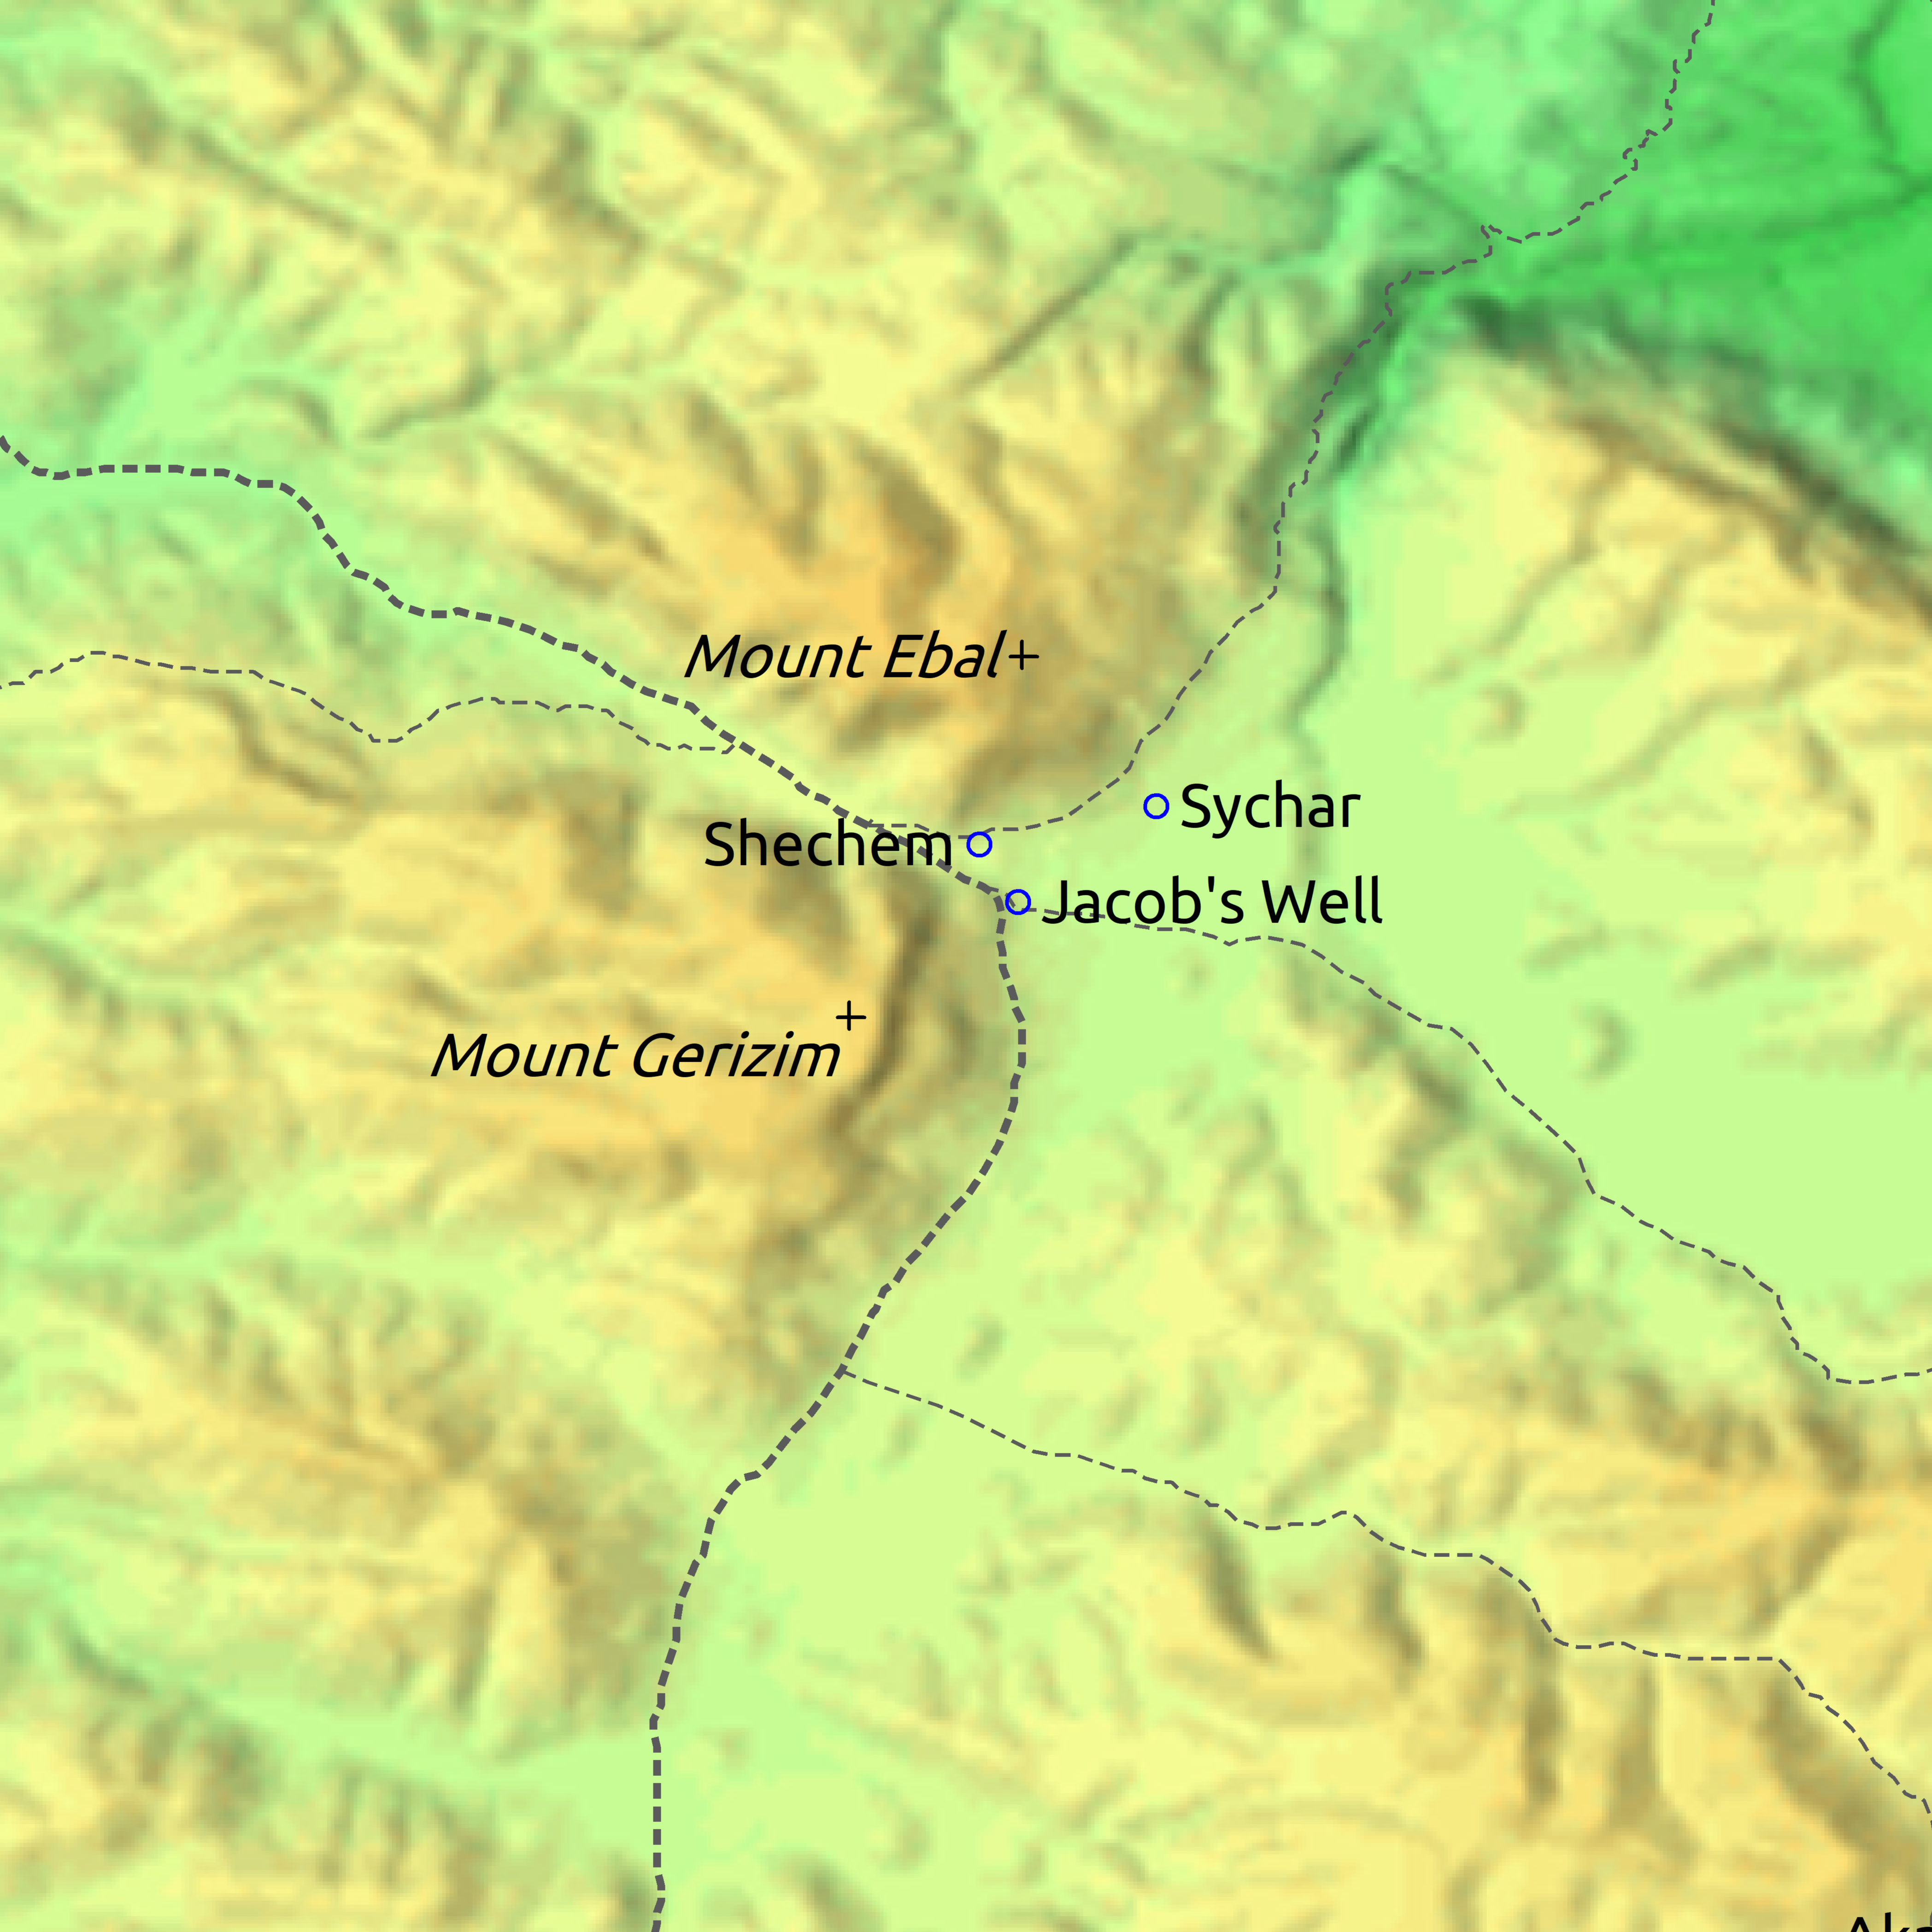
At Sychem^{G4966}/Shechem^{H7927} the LORD appears to Abram and promises the land to his seed. Abram builds an altar.
Joshua 8:30-32
After the battles at Jericho and Ai, Joshua builds an altar on mount Ebal and writes the law of Moses on the stones in the presence of the children of Israel.

Deuteronomy 27:1-8
Moses and the elders of Israel command the people to write the words of the law on great stones and they are to set the stones up on mount Ebal and an altar is to be built.

Deuteronomy 11:29, 27:11-13, Joshua 8:33
Moses charges the people that after they come over Jorden Simeon, Levi, Judah, Issachar, Joseph, and Benjamin will bless the people on mount Gerizim and Reuben, Gad, Asher, Zebulun, Dan, and Naphtali will curse from on mount Ebal. The Levites and the ark were in the middle of them (~Shechem).

Joshua 21:20,21
Shechem and its suburbs become a city of refuge for the slayer. Shechem was given to the Levite family of Kohathites, the children of Kohath, of which Moses, Aaron, and Miriam were descendants of (Exodus 6:16-20, Numbers 26:58,59).

Genesis 35:1-4
1 And God said unto Jacob, Arise, go up to Bethel, and dwell there: and make there an altar unto God, that appeared unto thee when thou fleddest from the face of Esau thy brother.
2 Then Jacob said unto his household, and to all that were with him, Put away the strange gods that are among you, and be clean, and change your garments:
3 And let us arise, and go up to Bethel; and I will make there an altar unto God, who answered me in the day of my distress, and was with me in the way which I went.
4 And they gave unto Jacob all the strange gods which were in their hand, and all their earrings which were in their ears; and Jacob hid them under the oak which was by Shechem.
- After Simeon and Levi slay Hamor and Shechem, Jacob is told by God to go to Bethel.
- Before they leave, Jacob buries their idols and earrings under a tree by Shechem.

Joshua 24:1
And Joshua gathered all the tribes of Israel to Shechem, and called for the elders of Israel, and for their heads, and for their judges, and for their officers; and they presented themselves before God.

Joshua 24:26
And Joshua wrote these words in the book of the law of God, and took a great stone, and set it up there under an oak, that was by the sanctuary of the LORD.
- After conquering the land of Canaan and distributing the inheritances to the tribes of Israel, the tabernacle is moved from Shiloh (Jos 18:10) to Shechem just before Joshua dies.

Judges 8:30-31, 9:1-57
³⁰ And Gideon had threescore and ten sons of his body begotten: for he had many wives.
³¹ And his concubine that was in Shechem, she also bare him a son, whose name he called Abimelech.
- Gideon/Jerubbaal’s son Abimelech becomes king of Israel for 3 years after slaying 70 of his brethren.
- He is made king by the men of Shechem and the house of Millo (Jdg 9:6).
- Gideon is the 5th judge God raised.
  - Delivered Israel from the Midianites.
  - The land was quiet (at peace?) for 40 years in the days of Gideon.

